Install or Upgrade NodeJS with NVM for Windows
Posted on marzo 28, 2017 by Daniel Arancibia Bohle — Deja un comentario
NVM (Node Version Manager) for Windows has become my favorite tool for installing or upgrading NodeJS (even you can downgrade it), the steps are as follows:
- Download and install NVM for Windows from github.com. The simplest option is to grab the installer version: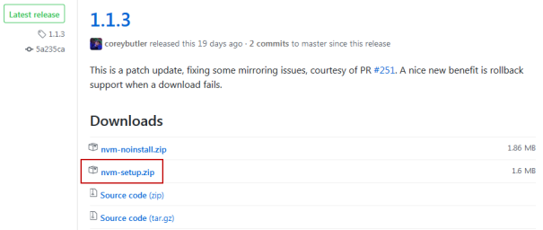
- As almost every Windows installer you just have to follow the wizard steps, this is just for completeness:
NVM Windows Installation Steps
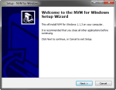  NVM Windows Installation Step 01 | 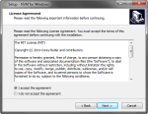  NVM Windows Installation Step 02 | 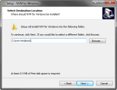  NVM Windows Installation Step 03  As the installation folder I’m using C:\nvm-windows.
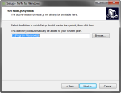  NVM Windows Installation Step 04 | 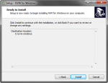  NVM Windows Installation Step 05 | 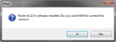  NVM Windows Installation Step 06  If you have Node previously installed this message will be shown, just select Yes.

- Open a command prompt (cmd.exe), and issue the command to download and install the latest version of NodeJS; this will detect your architecture automatically:
1  2 | C:\>nvm install latest  Downloading node.js version 7.7.4 (64-bit)...

You can select a previous version as well:

1  2 | C:\>nvm install 6.10.1  Downloading node.js version 6.10.1 (64-bit)...

You can download a 32 bit version:

1  2 | C:\>nvm install 6.10.1 32  Downloading node.js version 6.10.1 (32-bit)...

Notice: Selecting the latest version can download a non-LTS (Long Terms Support) version, for example, at the time of writing this, the latest version was the 7.7.4 (which isn’t LTS because of being an odd-numbered version); go to this link if you want to know the details about changes and fixes of NodeJS related to the numbering scheme.

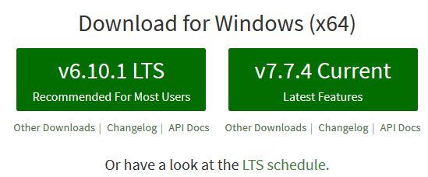

NodeJS versions download

- Finally issue the command to use the NodeJS:
1  2 | C:\>nvm use 7.7.4  Now using node v7.7.4 (64-bit)

You can use an 32 bit version as well:

1  2 | C:\>nvm use 7.7.4 32  Now using node v7.7.4 (32-bit)

